**Project Design Phase-II**

**Technology Stack (Architecture & Stack)**

|  |  |
| --- | --- |
| Date | 27 June 2025 |
| Team ID | LTVIP2025TMID59564 |
| Project Name | Edututor AI: personalized learning with generative AI and lms integration |
| Maximum Marks | 4 Marks |

**Technical Architecture:**

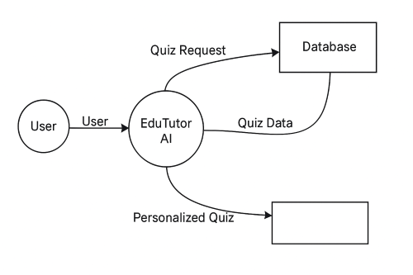

**Table-1 : Components & Technologies:**

|  |  |  |  |
| --- | --- | --- | --- |
| **S.No** | **Component** | **Description** | **Technology / Tools** |
| 1 | User Interface | Web App & Mobile App (chat + dashboard) | Streamlit (Web), Flutter (Mobile), HTML, CSS |
| 2 | Application Logic-1 | AI quiz generation from user topic & preferences | FastAPI, Python (LangChain, Prompt Templates, Moderation logic) |
| 3 | Application Logic-2 | Text analysis + RAG for better quiz generation | IBM Watsonx.ai (Granite LLM), Pinecone (vector search), LangChain |
| 4 | Application Logic-3 | Classroom management and quiz distribution | Google Classroom API integration |
| 5 | Database | Store quiz metadata, user details, history, and scores | PostgreSQL / SQLite |
| 6 | Cloud Database | |  | | --- | | Scalable remote storage of user data, logs, history | | IBM Cloudant / Firebase Cloud Firestore |
| 7 | File Storage | Save reports, exports, model logs, and uploaded files | |  | | --- | |  |   IBM Cloud Object Storage / Firebase Storage |
| 8 | External API-1 | Fetch context for improved quiz generation | Wikipedia API / Hugging Face inference APIs |
| 9 | External API-2 | User authentication & integration with LMS | Google OAuth2 / Classroom API |
| 10 | Machine Learning Model | Generate and evaluate quizzes from academic content | IBM Watsonx Granite (LLM), Text Moderation, RAG pipeline (LangChain) |
| 11 | Infrastructure | Backend deployment and app hosting | IBM Cloud / GCP / Streamlit Cloud / Firebase Hosting |

**Table-2: Application Characteristics:**

|  |  |  |  |
| --- | --- | --- | --- |
| **S.No** | **Characteristics** | **Description** | **Technology Used** |
| 1 | Open-Source Frameworks | UI and backend frameworks | Streamlit, FastAPI, Scikit-learn, Watsonx, LangChain |
| 2 | Security Implementations | Data encryption, role-based access, authentication | SHA-256, OAuth 2.0 (Google), .env Secrets, IAM Roles |
| 3 | Scalable Architecture | Microservice-ready, Firebase scaling, container deployment supported | FastAPI, Pinecone, Docker, Kubernetes-ready |
| 4 | Availability | 99.9% uptime via managed cloud infrastructure | IBM Cloud Load Balancer, Google Firebase Hosting (Multi-region) |
| 5 | Performance | Use of CDN for static content, async API, model inference <3 sec response | |  | | --- | |  |  |  | | --- | | Streamlit Caching, Firebase CDN, Watsonx Optimization, Async APIs | |

**References:**

[**https://c4model.com/**](https://c4model.com/)

[**https://developer.ibm.com/patterns/online-order-processing-system-during-pandemic/**](https://developer.ibm.com/patterns/online-order-processing-system-during-pandemic/)

[**https://www.ibm.com/cloud/architecture**](https://www.ibm.com/cloud/architecture)

[**https://aws.amazon.com/architecture**](https://aws.amazon.com/architecture)

[**https://medium.com/the-internal-startup/how-to-draw-useful-technical-architecture-diagrams-2d20c9fda90d**](https://medium.com/the-internal-startup/how-to-draw-useful-technical-architecture-diagrams-2d20c9fda90d)